**Assisted Practice: 4.3 Container Deployment Using Docker Swarm**

This section will guide you to**:**

* Deploy a Docker container on Docker swarm for orchestration.

This lab has four subsections, namely**:**

4.3.1 Setting up a Docker instance

4.3.2 Building a custom Docker image to be deployed

4.3.3 Initializing a Docker swarm cluster and deploying a container to the cluster

4.3.4 Pushing the code to GitHub repositories

**Step 4.3.1:** Setting up a Docker instance

* Docker version 18.09.7 is installed in your practice lab. (Refer FSD: Lab Guide - Phase 5)
* Type the following command to check the docker version installed on lab:

**docker version**

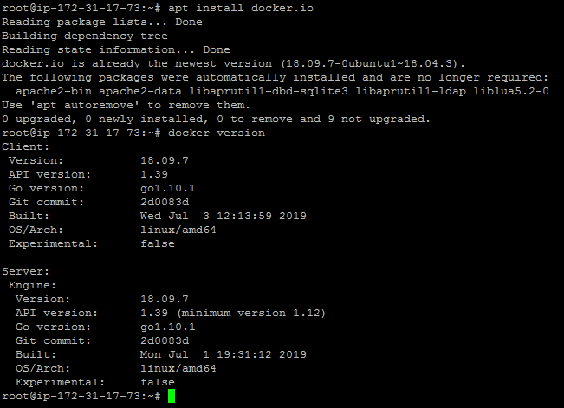

**Step 4.3.2:** Building a custom Docker image to be deployed

* First, clone the Git repository on Docker host using the command below:

**git clone** [**https://github.com/shashi1999/Docker.git**](https://github.com/shashi1999/Docker.git)

* Run with docker build command to build a custom Docker image

**cd Docker**

**docker build -t phpcode . -f Dockerfile**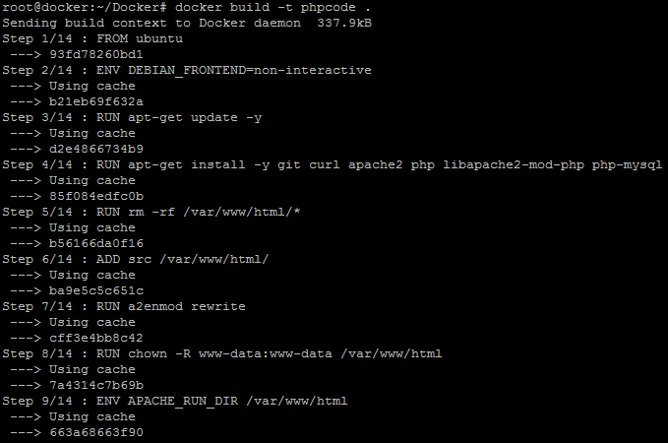

* Once the image is built, check if it is built properly or not. You can see a Docker image entry using Docker images command

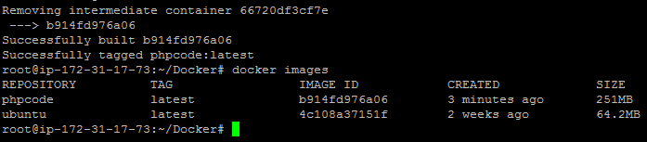

**Step 4.3.3:** Initializing a Docker swarm cluster and deploying a container to the cluster

* First, we need to initialize Docker swarm using the set of commands given below:

**docker swarm init**

**docker node ls**

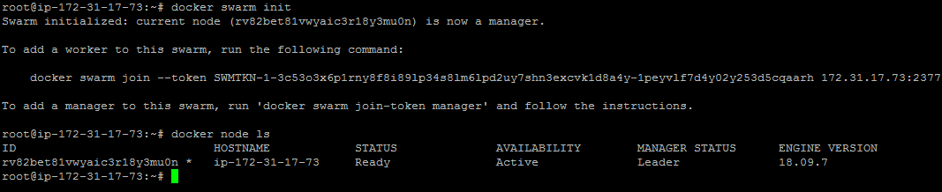

* Once the node is configured, deploy the custom Docker image on the Docker swarm cluster following the process shown below

**docker service create -p 80:80 --name webserver phpcode**

**docker service ls**

**curl localhost**

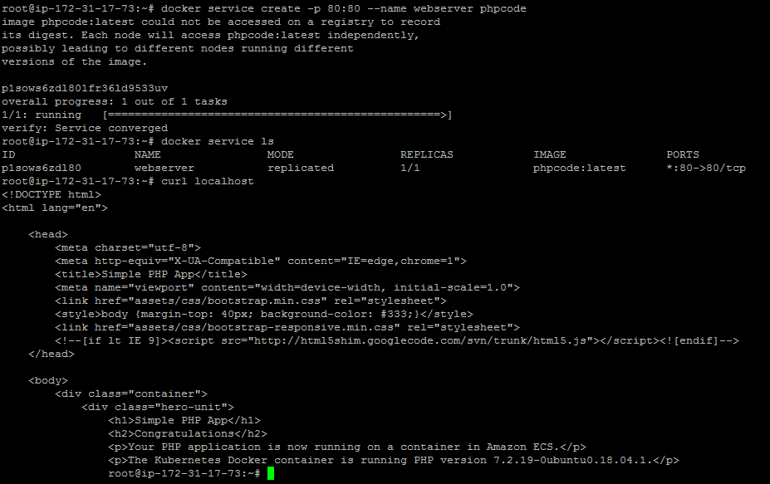

**Step 4.3.4:** Pushing the code to your GitHub repositories

* Open your command prompt and navigate to the folder where you have created your files.

**cd <folder path>**

* Initialize your repository using the following command:

**git init**

* Add all the files to your git repository using the following command:

**git add .**

* Commit the changes using the following command:

**git commit . -m “Changes have been committed.”**

* Push the files to the folder you initially created using the following command:

**git push -u origin master**